COST OF STUDIES
Permanent studies – 2000 EUR/year
Extended studies – 1500 EUR/year

ACCOMMODATION
All students are given an opportunity to live in a dormitory. All dormitories are conveniently located and well-equipped. There are one-bed and two-bed rooms in the dormitories with shared kitchens and bathrooms. Laundry service is also available.
The basic fee for the dormitory is 125 EUR/month.

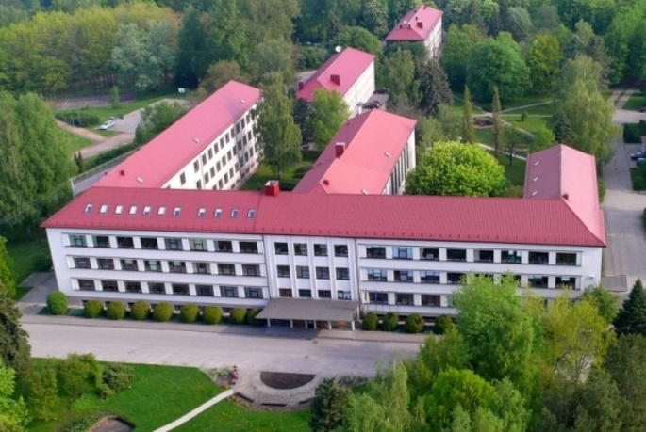

CONTACTS
Institution ERASMUS Coordinator – Inga Kibirkštienė
I.Kibirkstiene@kmaik.lm.lt

Department of Forestry – dr. Vidmantas Verbyla
V.Verbyla@kmaik.lm.lt

Department of Landscape Design and Recreation – Asta Doftartė
A.Doftarte@kmaik.lm.lt

Department of Hydrotechnical Engineering – dr. Ernesta Liniauskienė
E.Liniauskiene@gmail.com

Department of Real Estate Cadastre – dr. Edita Abalikštienė
E.Abalikstiene@kmaik.lm.lt

CONTACTS

Liepų str. 1, Girionys, LT-53101 Kaunas.reg., Lithuania
Webpage: www.kmaik.lt/en
E-mail: info@kmaik.lm.lt
Tel.: +370 37 383 082;
Mob. tel.: +370 609 62894

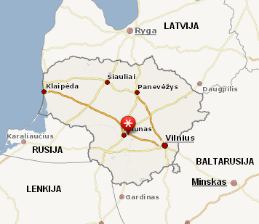
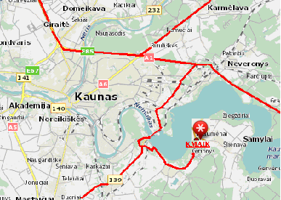

(KMAIK)

Join us!
Our doors are wide open for anyone interested in forestry, landscape architecture, nature tourism, horticulture, land management, cadastral measurements and real estate valuation, hydrotechnical and renewable energy engineering. Join us and you will find not only a modern system of education, but also human warmth, beautiful Lithuanian nature, rich history and fascinating traditions of our country. KMAIK provides higher non-university education – our graduates are awarded with Professional Bachelor's diplomas.

OUR STUDY PROGRAMS:

FORESTRY

Forest Growing
Timber Harvesting
Forest Management Planning and Inventory
Timber Processing
Special Forest Plantations

HYDROTECHNICAL ENGINEERING

Engineering Systems of Buildings (+“Smart House”)
External Water Management Systems
Renewable Energy Engineering

LANDSCAPE DESING

Landscape Architecture
Management of Urban Green Areas
Park Planning
Growing of Ornamental Plants

CADASTRAL MEASUREMENTS OF REAL ESTATE

Real Estate Cadastre
Real Estate Formation and Valuation



HORTICULTURE

Horticultural Business
Urban and Ornamental Horticulture
"Smart" Garden

LAND MANAGEMENT

Land Administration
Territorial Planning

DURATION OF STUDIES FOR BACHELOR’S DEGREE
Permanent studies – 3 years.
Extended studies – 4 years.

A great attention is paid to the practical training at the University – nearly 30% of study time is allocated to various educational practices and apprenticeships.

There is a possibility to study in other European universities for up to 6 months under ERASMUS programme. Depending on country, the student gets a scholarship of 350-600 EUR per month.

APPLYING

The following documents should be provided prior to signing the Study Agreement:
- General Certificate of Secondary Education
- A Valid Passport
- Medical Insurance
- Visa (if necessary).

